Japan Poultry Science Association (JPSA)
Application for Membership

To the President of the JPSA
I apply to join the membership of the JPSA from (year)
Name: | (Family) |  | (Middle) |  |  |  | (Given)
Title | □ Prof. | □ Dr. |  |  | □ Mr. |  |  | □ Ms.
Birth Date | (day) (month) (year)
Institute
Address
Country |  |  |  | Postal Code
Additional Information | If you wish to have the printed copies of the journal at your home, please fill out your home address.
AGREEMENT and SIGNATURE
I Confirm and Understand that:
- Information provide here is true and correct.
- By signing this document, I agree to abide by the conditions of membership as laid out in the rules of the JPSA.
- Members (excluding special international members) can receive the printed copies of the journal.
- Members can join the meetings and publish their paper(s) at a membership price.
- If any of the provided information is ‘False’ or ‘Misleading’, or if anything is done that is deemed to be against the interests of the JPSA that my lead to terminate the membership. E.g., plagiarism.
- To withdraw the membership from the JPSA, it is necessary to send a withdrawal notice to the JPSA Office
(jpsa-s@naro.affrc.go.jp) by the end of February.
Date
Signature
Name and signature of supervisor in case of student membership
Title and Name (type):
Signature:

Type of the membership (Give a mark):
Mark | Type of the membership | Membership Due  (yen/year) | Membership | Notes
 | Regular Member A | 10,000 | JPSA and WPSA
 | Regular Member B | 7,000 | JPSA
 | Student Member A | 4,500 | JPSA and WPSA
 | Student Member B | 3,000 | JPSA
 | Sustaining Member A | 47,000 | JPSA and WPSA
 | Sustaining Member B | 40,000 | JPSA
 | Special International Member | 50US$ | JPSA | Residing Abroad
What is the JPSA official service to each membership?
Please see URL at https://jpn-psa.jp/en/membership/

Please send this form to:
Secretarial Office, Japan Poultry Science Association,
Institute of Livestock and Grassland Science, NARO
2 Ikenodai, Tsukuba, Ibaraki 305-0901, Japan
(E-mail; jpsa-s@naro.affrc.go.jp)

Please send the membership fee to:
We offer three payment methods; Postal transfer, Bank transfer and PayPal.

Postal transfer
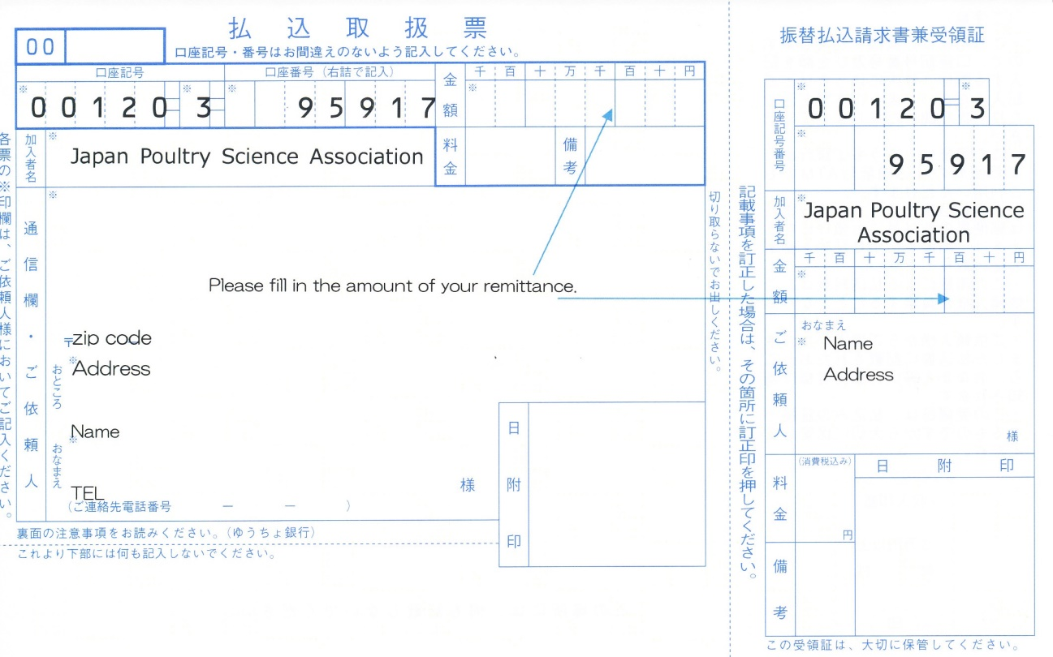
Bank transfer
Account No.: 3060994 (Ordinary Deposit)
Name: Japan Poultry Science Association President Mitsuhiro Furuse
Sumitomo Mitsui Banking Corporation, Ushiku Branch
Bank Address: Ushiku City, Ibaraki 300-1221, Japan
Swift Code: SMBCJPJT (Bank Code: 0009 Branch Code: 012)

※Bank transfer fee is not included in the membership fee. Please burden this at your expense.

PayPal
If you would like to pay your membership fee by PayPal, please contact us.
Email: jpsa-s@naro.affrc.go.jp

※ PayPal Handling fee is not included in the membership fee. PayPal Handling Fee of 4% will be added to your bill.

Regarding Membership Withdrawal Notices

Your membership is renewed automatically every year; it will not automatically be terminated at the end of the membership period. Those who join in order to give presentations at academic meetings must also submit a withdrawal notice.
Annual membership fees for the period from March to February should be paid by the end of the preceding December. If payment is not received by the end of December, your membership will still be renewed unless you submit a withdrawal notice by the end of the February following.
We do not contact members about renewing their annual membership; therefore, if you wish not to do so, you must submit a withdrawal notice by the end of the membership period in February.
A withdrawal notice received on or after March 1st, within the new membership period, will not be considered valid.
Withdrawal notices must be submitted in writing via email, fax, or post. Please note that we do not accept withdrawal notices by phone or verbal communication.
Termination of membership generally takes effect at the end of February (the end of the membership period). We do not permit monthly, quarterly, or other forms of partial membership, nor can we reimburse members for the unused portion of their membership fees.
Note: If you owe any outstanding fees, we will defer accepting and processing your withdrawal notice until your fees are paid in full. Please pay any outstanding fees as soon as possible.

Although there is no specific format required for withdrawal notices, please include your membership number, full name, reason for and date of withdrawal, and send your notice to the Association office.

Japan Poultry Science Association Withdrawal Notice
Attn: President of the Japan Poultry Science Association
- Membership number (can be omitted if unknown)
- Full name
- Reason for withdrawal
- Date of withdrawal

