Regarding Membership Withdrawal Notices
Your membership is renewed automatically every year; it will not automatically be terminated at the end of the membership period. Those who join in order to give presentations at academic meetings must also submit a withdrawal notice.
Annual membership fees for the period from March to February should be paid by the end of the preceding December. If payment is not received by the end of December, your membership will still be renewed unless you submit a withdrawal notice by the end of the February following.
We do not contact members about renewing their annual membership; therefore, if you wish not to do so, you must submit a withdrawal notice by the end of the membership period in February.
A withdrawal notice received on or after March 1st, within the new membership period, will not be considered valid.
Withdrawal notices must be submitted in writing via email, fax, or post. Please note that we do not accept withdrawal notices by phone or verbal communication.
Termination of membership generally takes effect at the end of February (the end of the membership period). We do not permit monthly, quarterly, or other forms of partial membership, nor can we reimburse members for the unused portion of their membership fees.
Note: If you owe any outstanding fees, we will defer accepting and processing your withdrawal notice until your fees are paid in full. Please pay any outstanding fees as soon as possible.

Although there is no specific format required for withdrawal notices, please include your membership number, full name, reason for and date of withdrawal, and send your notice to the Association office.

Japan Poultry Science Association Withdrawal Notice
Attn: President of the Japan Poultry Science Association
- Membership number (can be omitted if unknown)
- Full name
- Reason for withdrawal
- Date of withdrawal

You can pay your fee by Postal Transfer, Bank Transfer or Paypal.

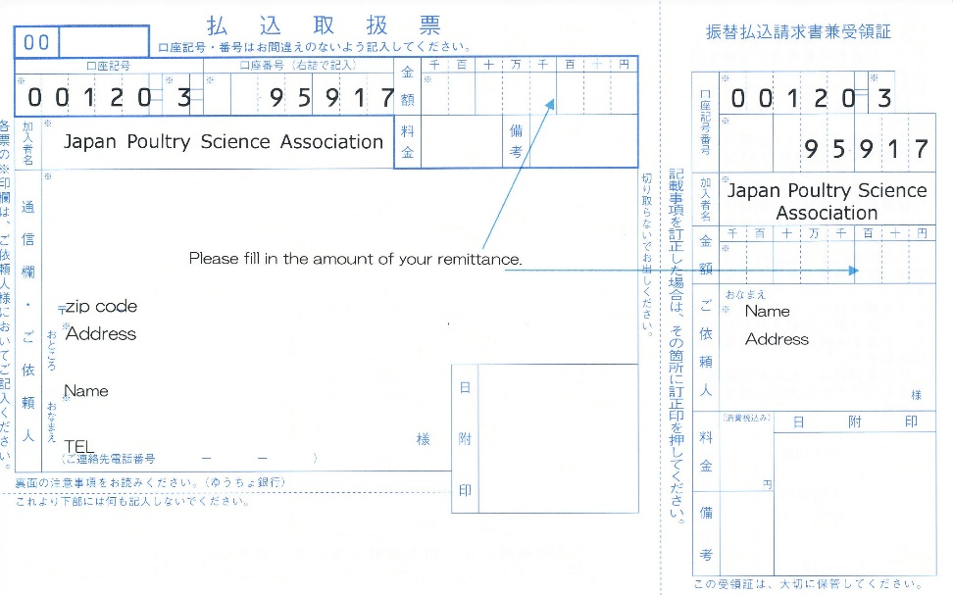
Postal transfer

Bank transfer
Account No.: 3060994 (Ordinary Deposit)
Name: Japan Poultry Science Association President Kazuaki Takahashi
Sumitomo Mitsui Banking Corporation, Ushiku Branch
Bank Address: Ushiku City, Ibaraki 300-1221, Japan
Swift Code: SMBCJPJT (Bank Code: 0009 Branch Code: 012)

※Bank transfer fee is not included in the membership fee. Please burden this at your expense.

PayPal
If you would like to pay your membership fee by PayPal, please contact us.
Email: jpsa-s@naro.affrc.go.jp

※PayPal Handling fee is not included in the membership fee. PayPal Handling Fee of 4% will be added to your bill.

*****************************************************
Japan Poultry Science Association
Institute of Livestock and Grassland Science, NARO
2 Ikenodai, Tsukuba, Ibaraki, 305-0901, Japan
E-mail; jpsa-s@naro.affrc.go.jp
*****************************************************

